# About APIGA Cambodia

The **Asia Pacific Internet Governance Academy (APIGA) Cambodia** is a youth-focused capacity-development program designed to strengthen understanding and engagement in Internet governance among Cambodian youth. The program is a **locally-driven initiative**, founded by APIGA alumni and a group of passionate young leaders in Internet governance, including contributors from [**YIGF Cambodia**](https://yigfkh.org/). It aims to empower youth to actively participate in shaping Cambodia’s digital future.

The two-day in-person program, preceded by a preparatory online session, will take place in **Phnom Penh, Cambodia, from 6–7 December 2025**. APIGA Cambodia builds on the original [**Asia Pacific Internet Governance Academy (APIGA)**](https://icann-community.atlassian.net/wiki/spaces/GSEAPAC/pages/114299302/Asia+Pacific+Internet+Governance+Academy), a regional capacity-building program organized by [**Internet Corporation for Assigned Names and Numbers (ICANN)**](https://www.icann.org/) **and** [**the Korea Internet & Security Agency (KISA)**](https://www.kisa.or.kr/EN), but localizes the content and discussions to address Cambodia’s specific Internet governance context, challenges, and opportunities.

This year, [**Open Development Cambodia (ODC)**](https://opendevelopmentcambodia.net/) leads the organization of APIGA Cambodia, with the support of the [**Ministry of Post and Telecommunications (MPTC)**](https://mptc.gov.kh/en/), [**ICANN**](http://icann.org)**,** [**Internet Society**](https://www.internetsociety.org/)**,** [**NetMission**](https://netmission.asia/)**, and** [**DotAsia**](https://www.dot.asia/).

# Preparation Month (20 - 30 November 2025)

## Information and Introduction

In preparation for the in-person program of Local APIGA Cambodia 2025, all selected participants are required to complete the assigned **online self-learning courses and reading materials** by **30 November 2025, 11:59 p.m.**  
Failure to complete these materials within the deadline may result in **ineligibility to participate** in the Local APIGA Cambodia program.

**Important Notes:**

1. Please use the **same name and email address** from your application when creating your online learning accounts. Your progress and completion status will be tracked using this information. If you registered with a different email address, please contact [info@apigacambodia.org](mailto:info@apigacambodia.org) for assistance.
2. If you have previously completed any of the required online courses, please send **proof of completion (e.g., certificates)** to [info@apigacambodia.org](mailto:info@apigacambodia.org)

### APNIC Academy

**Step 1**: Register for an account or log in to the APNIC Academy (<https://academy.apnic.net/en/>). When registering, please check your spam/junk folder if you do not receive any email from the APNIC Academy system.

**Step 2**: Complete the following courses:

* [Internet Resource Management](https://academy.apnic.net/en/course/internet-resource-management-course) (~120 mins)
* [Routing Fundamentals](https://academy.apnic.net/en/course/routing-fundamentals-course) (~60 mins)
* [Cybersecurity Fundamentals](https://academy.apnic.net/en/course/cybersecurity-fundamentals) (~120 mins)

### ICANN Learn

**Step 1**: Log in to ICANN Learn (<https://learn.icann.org/>) with your ICANN Account credentials or create a new account if you do not have one.

**Step 2**: Complete the following courses:

* 102.1 Introduction to ICANN (~37 mins)
* 103 ICANN Public Meetings for Newcomers (~20 mins)
* 500 Policy Development Fundamentals (~40 mins)
* 503 Policy Development Processes (~45 mins)
* 605 Introduction to Universal Acceptance (~25 mins)

### ISOC Learning

**Step 1**: Click Register on the login box at [learning.internetsociety.org](http://learning.internetsociety.org). Next, either register as a member or click on the guest registration form to register as a guest. Once you create an account, you can use the credentials you created to log in.

**Step 2**: You will need to complete the following courses:

* What the Internet Needs to Exist:  
   <https://www.internetsociety.org/learning/iwn/>
* What the Internet Needs to Thrive:  
  <https://www.internetsociety.org/learning/what-internet-needs-to-thrive/>

## Introductory session:

1. **On November 20th, 2025**, we will hold an introductory session with all participants to discuss the program’s objectives and structure, as well as to provide an opportunity for everyone to get to know one another. This session will help set expectations, address initial questions, and build a sense of community among participants. Session access details will be shared closer to the date.
2. **On November 25th, 2025**, Following the introductory session, we will hold an ICANN Model Preparation Session with all participants and mentors. During this session, participants will begin developing their assigned positions and gain a deeper understanding of the conference structure and expected outcomes. This collaborative workshop aims to equip everyone with the necessary knowledge and guidance to actively engage in the upcoming Model ICANN Conference.

Please note that attendance is mandatory for all participants. In case of an emergency, you must inform us via [**info@apigacambodia.org**](mailto:info@apigacambodia.org)at least one day in advance.

## Program Agenda:

Please refer to link below for the two-day program schedule:   
Program | APIGA Cambodia 2025

# 

# Model ICANN Conference Infokit

This information kit is designed to assist participants in preparing for the ICANN Model Conference. This document contains comprehensive information regarding the Model Conference topic, including details about preparation sessions and roleplay discussions. Additionally, it offers guidance on how to effectively prepare for the Model Conference.

**Table of Contents**

**Introduction** **1**

**Topic** **2**

**ICANN Model Conference** **2**

Etiquette for the ICANN Model Conference 2

What to Expect at the ICANN Model Conference 3

ICANN Model Conference Seating Arrangement 4

**Agenda and Session Format** **4**

**Group List** **8**

**Assigning Group Responsibilities and Formulating Positions** **11**

**Role Descriptions** **13**

Governmental Advisory Committee (GAC) 13

At-Large Advisory Committee (ALAC) 14

Generic Names Supporting Organisation (GNSO) 16

**Appendix 1: Group Dynamics** **17**

**Appendix 2: ICANN Expected Standards of Behavior** **17**

# 

# 

# Introduction

For the ICANN Model Conference exercise, all participants will be assigned to 1 of the following 3 groups:

* Governmental Advisory Committee (GAC)
* At-Large Advisory Committee (ALAC)
* Generic Names Supporting Organization (GNSO)

# Understanding and Addressing DNS Abuse: Strengthening Trust in the Internet

The Domain Name System (DNS) is a fundamental part of how the Internet works, it translates domain names (like *example.com*) into IP addresses that computers use to communicate. However, the DNS can also be misused by malicious actors for harmful activities such as phishing, malware distribution, botnets, and spam. These activities are collectively known as **DNS abuse**.

At ICANN, addressing DNS abuse is an ongoing priority involving collaboration among governments, businesses, civil society, and end-users. While ICANN itself does not police the Internet, it develops policies and coordinates actions with registries, registrars, and the broader community to reduce abuse and promote a safer online environment.

This topic invites participants to explore how different stakeholders can work together to reduce DNS abuse, protect users, and maintain trust in the Internet ecosystem.

# ICANN Model Conference

A fundamental part of ICANN’s mission is to coordinate policy development related to the Internet’s unique identifier systems.

Policy recommendations are developed by the ICANN community through the Supporting Organizations (SOs), with input and advice from the Advisory Committees (ACs). The ICANN community consists of global volunteers from different stakeholder groups. Adopting the multistakeholder model, policies are developed through a multistakeholder, “bottom-up”, consensus-driven approach.

The "Model ICANN Conference" is a role-play exercise similar to Model United Nations. However, instead of simulating a country's stance on global political issues, participants representing the views of different stakeholders build consensus on Internet governance related topics. Based on assigned roles, participants will portray different positions across different stakeholder groups. From this exercise, participants will experience the dynamics of policy development discussions within the ICANN community.

| **Problem Statement** |
| --- |
| **Problem Statement 1:** How can the ICANN community and its stakeholders collaborate more effectively to detect and mitigate DNS abuse while maintaining an open and secure Internet?  **Problem Statement 2:** What responsibilities should different stakeholder groups GAC, GNSO, ALAC have in addressing DNS abuse? |

## *Etiquette for the ICANN Model Conference*

Below are some common etiquettes at ICANN meetings. Here are some “dos” and “don’ts” for the ICANN Model Conference.

* Raise your hand if you want to speak. Wait until you are given the floor by the moderator before making a comment or statement.
  + The model conference moderator will keep a queue to allow equal opportunities for all participants to speak.
* Mention your name and affiliation before you speak.
* Keep your comment and statement to the point. Keep it concise.
* Respect others’ opinions. Use respectful language and avoid personal attacks or derogatory remarks.
* Give everyone a chance to speak. Avoid dominating the discussion and don’t interrupt while someone else is speaking.

## *What to Expect at the ICANN Model Conference*

Participants will work within their stakeholder groups to research the model conference topic, understand their assigned roles, and develop policy positions in response to the given problem statements.

This preparation culminates in the **ICANN Model Conference** on **Day 2**, where participants will apply their knowledge and teamwork in a simulated policy development process involving structured discussions and sharing of different perspectives across stakeholder groups, aiming to achieve consensus on the problem statements.

Details breakdown for each preparation session and the simulation exercise are below. Broad guidelines on what is expected are as follows:

* **Stakeholder Group Breakouts & Role-Based Preparation**
  + Participants will break out into their stakeholder groups i.e., GAC, ALAC, and GNSO, to research the simulation topic and understand their respective roles. Each group will assign responsibilities (Chair, Vice Chair, Notetaker, and Spokesperson) to structure their in-group discussion and work. Based on the assigned roles, participants will prepare their positions and arguments for the assigned problem statements.
* **Position Development and Preparation**
  + In addition to positions for the assigned roles, participants will also work on a collective stakeholder group (i.e. GAC, ALAC, and GNSO) position. Throughout this process, mentors from the ICANN community and youth leaders will offer feedback and guidance to participants.
* **Cross-Community Breakout discussion** 
  + To encourage deeper engagement and inter-stakeholder group discussions, participants will join cross-community breakout discussions designed to build consensus around the problem statements.
  + Groups must note other stakeholder groups’ positions throughout the discussions to facilitate cross-community conversations towards building consensus.
* **Plenary**
  + The ICANN Model Conference exercise on Day 2 will bring all stakeholder groups together in a full plenary. This exercise will allow each stakeholder group, as well as individual roles within the groups, to share their positions on the problem statements. The aim of the exercise is to reach a consensus on the problem statements.

## *ICANN Model Conference Seating Arrangement*

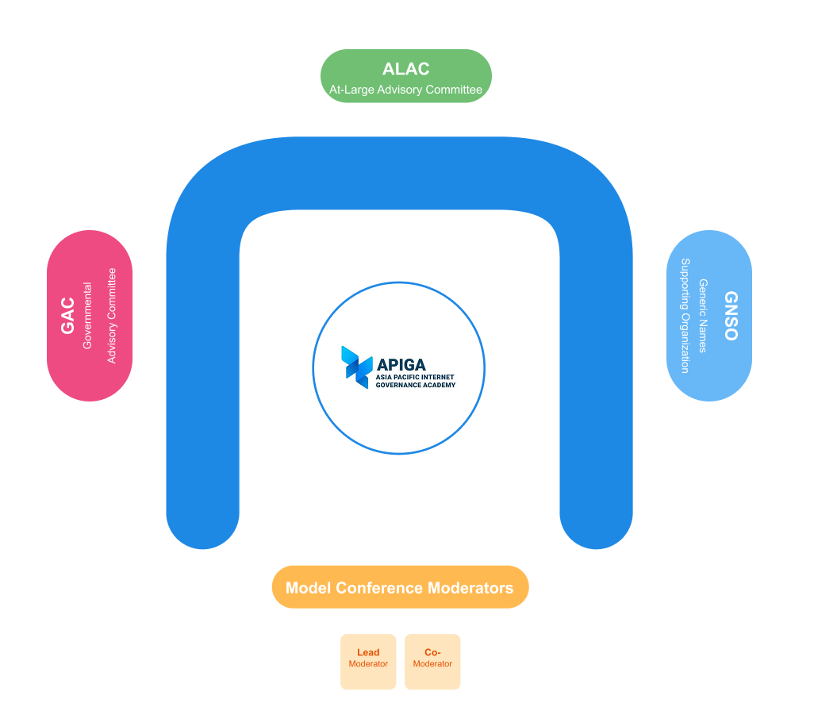

# 

# Group List

| **GAC**  **Mentors: Kimhong Set & Yien Chyn Tan**  **Youth leaders: Srymanit Huot, Honey HongTholly** | | | |
| --- | --- | --- | --- |
| **N** | **Name** | **Gender** | **School/Organization** |
| 1 |  |  |  |
| 2 |  |  |  |
| 3 |  |  |  |
| 4 |  |  |  |
| 5 |  |  |  |
| 6 |  |  |  |
| 7 |  |  |  |
| 8 |  |  |  |
| 9 |  |  |  |
| 10 |  |  |  |

| **ALAC**  **Mentors: Socheata Sokhachan**  **Group leaders: Sammakara Mak, Lam Sotheary** | | | |
| --- | --- | --- | --- |
| **S/N** | **Name** | **Gender** | **School/Organization** |
| 1 |  |  |  |
| 2 |  |  |  |
| 3 |  |  |  |
| 4 |  |  |  |
| 5 |  |  |  |
| 6 |  |  |  |
| 7 |  |  |  |
| 8 |  |  |  |
| 9 |  |  |  |
| 10 |  |  |  |

| **GNSO**  **Mentors: Chanvoleak Ros**  **Group leaders: Morokot Huoth, Lita Than** | | | |
| --- | --- | --- | --- |
| **S/N** | **Name** | **Gender** | **School/Organization** |
| 1 |  |  |  |
| 2 |  |  |  |
| 3 |  |  |  |
| 4 |  |  |  |
| 5 |  |  |  |
| 6 |  |  |  |
| 7 |  |  |  |
| 8 |  |  |  |
| 9 |  |  |  |
| 10 |  |  |  |

# Assigning Group Responsibilities and Formulating Positions

This section will provide you with information on the responsibilities of chairs, vice-chairs, notetakers, and spokespersons within each group. You will also learn the modalities of formulating your positions on the problem statements of the ICANN conference.

*Note: Every participant is encouraged to share your views and arguments during the model conference, regardless of whether you are the spokesperson for your group.*

Organize your group to take on the following responsibilities:

| **Chair**   * The Chair’s key role will be to formulate (and decide) the group’s positions on the problem statements.   + The Chair will facilitate discussions within the group and ensure all views are heard. * The Chair will also facilitate conversations with other groups as needed. * The Chair has the right to nominate spokespersons to speak on behalf of the group during the plenary. | **Vice Chair**   * The Vice Chair’s role is to assist the Chair (e.g., facilitating discussion within the group, deciding on final positions, etc.). * The Vice-Chair will also facilitate conversations with other groups as needed. |
| --- | --- |
| **2 x Notetakers**   * Notetakers have the important task of noting discussion points. * It is crucial to note statements and positions of other groups to determine whether you share the same positions, and to facilitate your group’s discussion when working on a consensus with other groups. * Notetakers will prepare a Google document and share their screen during the in-group discussions. | **Spokespersons (group/Chair to decide how many)**   * Spokespersons will speak on behalf of the group during the plenary. They will deliver the group’s agreed-upon views and positions on the problem statements.   + Spokespersons can also speak in their own capacity based on their assigned roles. * The Chair has the right to nominate spokespersons if no one volunteers. |

**Formulate your positions**

**Problem Statement 1:**

**Problem Statement 2:**

* Your aim is to achieve consensus with the other groups on the above 2 problem statements.
* Establish early on whether you are willing to forgo or update selected positions from your in-group agreed list– your group can decide whether to adopt views from other groups or to convince/“force” others to adopt yours.
* As your group hears from other groups on their positions, you can also add other expectations as you see fit – they can be used as “bargaining chips”.
* When making your statements, cite some examples so other groups can understand exactly what you mean.

# 

# Role Descriptions

Participants have the option to partner up with another participant in your group, or to work individually. There will be a limit of 3 pairs of partners in each group, first-come-first served. Participants to finalize partnering up and role selection by the end of 10 Aug 2025. The following descriptions aim to provide you with an understanding of your roles for the ICANN Model Conference.

| Governmental Advisory Committee (GAC) GAC serves as the voice of Governments and International Governmental Organisations. The key role of GAC is to provide advice to ICANN on issues of public policy, especially where there is an interaction between ICANN’s activities/policies and international agreements/national laws.  The GAC regularly considers a broad range of public policy issues impacting the DNS and many substantive policy topics, as well as operational matters impacting the work of ICANN. This work can result in consensus advice for the ICANN Board or public comment input during the policy development process (PDP).  Advice from the GAC to ICANN is determined on the basis of consensus. Advice is conveyed to the ICANN Board, usually in the form of a communiqué issued at the end of each GAC meeting through the Chair of the GAC. Each communiqué and the minutes of GAC meetings are made available online. |
| --- |
|  |
|  |
|  |
|  |
|  |
|  |
|  |
|  |
|  |
|  |
|  |
|  |

| At-Large Advisory Committee (ALAC) The At-Large Advisory Committee (ALAC) is the primary organizational home within ICANN for individual Internet users. **While** the ALAC itself is a 15-member committee, its members are mostly selected from the Internet user community it gathers -- known as the At-Large Community -- which is much bigger and wider. There are 256 At-Large Structures (ALSes) and 240 Individual Members based in 113 countries spanning the 5 ICANN regions of the world. The role of the ALAC is to consider and provide advice on the activities of ICANN, insofar as they relate to the interests of individual Internet users. The 15-member ALAC consists of two members selected by each of the five Regional At-Large Organisations (RALOs) and five members appointed by ICANN’s Nominating Committee, with one appointee from each ICANN geographic region. The 5 RALOs are AFRALO (Africa), APRALO (Asia Pacific), EURALO (Europe), LACRALO (Latin America & the Caribbean) and NARALO (North America).  Advocating for the interests of end-users, the ALAC advises on the activities of ICANN, including Internet policies developed by ICANN’s Supporting Organizations. The ALAC also participates in ICANN’s outreach and engagement programs. |
| --- |
|  |
|  |
|  |
|  |
|  |
|  |
|  |
|  |
|  |
|  |
|  |
|  |

| Generic Names Supporting Organisation (GNSO) The Generic Names Supporting Organisation (GNSO) is responsible for shaping and recommending changes to policies concerning generic Top-Level Domains (gTLDs). Navigating diverse (and often contentious interests) across its two main houses– the Contracted Parties House (CPH) and the Non-Contracted Parties House (NCPH). The GNSO plays a crucial role in developing and suggesting changes to gTLD policies through a structured process involving various stakeholder groups and houses, ensuring a fair and balanced approach to Internet governance. The primary objective of the GNSO is to ensure that gTLDs operate in a fair and orderly manner across the global Internet, promoting innovation and competition without compromising stability.  **GNSO Structure**   1. **Contracted Parties House (CPH):**    * **Registry Stakeholder Group (RySG):** Represents entities that operate gTLD registries.    * **Registrar Stakeholder Group (RrSG):** Represents entities that act as registrars for gTLDs. 2. **Non-Contracted Parties House (NCPH):**    * **Commercial Stakeholder Group (CSG):**      + Intellectual Property Constituency (IPC)      + Business Constituency (BC)      + Internet Service Providers and Connectivity Providers Constituency (ISPCP)    * **Non-Commercial Stakeholder Group (NCSG):**      + Not-for-Profit Organizations Constituency (NPOC)      + Non-Commercial Users Constituency (NCUC) |
| --- |
|  |
|  |
|  |
|  |
|  |
|  |
|  |
|  |
|  |

# Appendix 1: Group Dynamics

To ensure that every group will have a productive and collaborative environment, this section provides tips on handling group dynamics and on finding ways to reach a consensus.

* Be attentive when others speak.
* Use inclusive language and respect the diversity of participants.
* Find ways to fill gaps and reach a consensus that considers all participants’ viewpoints.
* Respect contrasting viewpoints and be adaptive to alternative opinions.
* Provide recognition to other group members, acknowledging their contributions and encouraging their continued participation.
* Encourage group members to take ownership of their work and to take initiative towards driving the group’s success.

# Appendix 2: ICANN Expected Standards of Behavior

[ICANN Expected Standards of Behavior](https://www.icann.org/en/system/files/files/expected-standards-15sep16-en.pdf)

Those who take part in ICANN multi-stakeholder process, including Board, staff, and all those involved in Supporting Organization and Advisory Committee councils, undertake to:

* Act in accordance with ICANN's Bylaws. In particular, participants undertake to act within the mission of ICANN and in the spirit of the values contained in the Bylaws.
* Adhere to ICANN's conflict of interest policies.
* Treat all members of the ICANN community equally, irrespective of nationality, gender, racial or ethnic origin, religion or beliefs, disability, age, or sexual orientation; members of the ICANN community should treat each other with civility both face-to-face and online.
* Respect all members of the ICANN community equally, behave in a professional manner, and demonstrate appropriate behavior. ICANN strives to create and maintain an environment in which people of many different backgrounds and cultures are treated with dignity, decency, and respect. Specifically, participants in the ICANN process must not engage in any type of harassment. Generally, harassment is considered unwelcome hostile or intimidating behavior -- in particular, speech or behavior that is sexually aggressive or that intimidates based on attributes such as race, gender, ethnicity, religion, age, color, national origin, ancestry, disability or medical condition, sexual orientation, or gender identity.
* Act in a reasonable, objective and informed manner when participating in policy development and decision-making processes. This includes regularly attending all scheduled meetings and exercising independent judgment based solely on what is in the overall best interest of Internet users and the stability and security of the Internet's system of unique identifiers, irrespective of personal interests and the interests of the entity to which an individual might owe their appointment.
* Listen to the views of all stakeholders when considering policy issues. ICANN is a unique multi-stakeholder environment. Those who take part in the ICANN process must acknowledge the importance of all stakeholders and seek to understand their points of view.
* Work to build consensus with other stakeholders in order to find solutions to the issues that fall within the areas of ICANN's responsibility. The ICANN model is based on a bottom-up, consensus driven approach to policy development. Those who take part in the ICANN process must take responsibility for ensuring the success of the model by trying to build consensus with other participants.
* Facilitate transparency and openness when participating in policy development and decision-making processes.
* Support the maintenance of robust mechanisms for public input, accountability, and transparency to ensure that policy development and decision-making processes will reflect the public interest and be accountable to all stakeholders.
* Conduct themselves in accordance with ICANN policies.
* Protect the organization's assets and ensure their efficient and effective use.
* Act fairly and in good faith with other participants in the ICANN process.
* Promote ethical and responsible behavior. Ethics and integrity are essential, and ICANN expects all stakeholders to behave in a responsible and principled way.